EXP. NO: 9
PERFORMANCE EVALUATION OF AM GENERATION AND DETECTION UNDER NOISY CHANNEL CONDITIONS USING MATLAB
Objectives:
i) To generate an Amplitude Modulated (AM) signal, introduce Additive White Gaussian Noise
(AWGN), and analyze the effect of noise on the transmitted signal using MATLAB.
PROGRAMMING CODE:
clc;
clear;
close all;

% Given Parameters
Am = 1; % Message signal amplitude
Ac = 2; % Carrier signal amplitude
fm = 100; % Message frequency in Hz
fc = 1000; % Carrier frequency in Hz
mu = 0.8; % Modulation index
SNR = 10; % Signal-to-Noise Ratio in dB

% Sampling Parameters
fs = 10000; % Sampling frequency in Hz
T = 0.05; % Duration in seconds
t = 0:1/fs:T-1/fs;

% Generate Message Signal
m = Am*cos(2*pi*fm*t);

% Generate Carrier Signal
c = Ac*cos(2*pi*fc*t);

% Generate AM Signal
s = Ac*(1 + mu*cos(2*pi*fm*t)).*cos(2*pi*fc*t);

% Add AWGN Noise
signal_power = mean(s.^2);
noise_power = signal_power/(10^(SNR/10));
noise = sqrt(noise_power)*randn(size(s));

% Received Signal
r = s + noise;

% Display SNR
measured_SNR = 10*log10(mean(s.^2)/mean(noise.^2));

fprintf('Modulation Index = %.2f\n',mu);
fprintf('Specified SNR = %.2f dB\n',SNR);
fprintf('Measured SNR = %.2f dB\n',measured_SNR);

% Plot Signals
figure;

subplot(4,1,1);
plot(t,m);
title('Message Signal');
xlabel('Time (s)');
ylabel('Amplitude');
grid on;

subplot(4,1,2);
plot(t,s);
title('Generated AM Signal');
xlabel('Time (s)');
ylabel('Amplitude');
grid on;

subplot(4,1,3);
plot(t,noise);
title('Additive White Gaussian Noise (AWGN)');
xlabel('Time (s)');
ylabel('Amplitude');
grid on;

subplot(4,1,4);
plot(t,r);
title(['Received AM Signal with AWGN, SNR = ',num2str(SNR),' dB']);
xlabel('Time (s)');
ylabel('Amplitude');
grid on;
OUTPUTS:
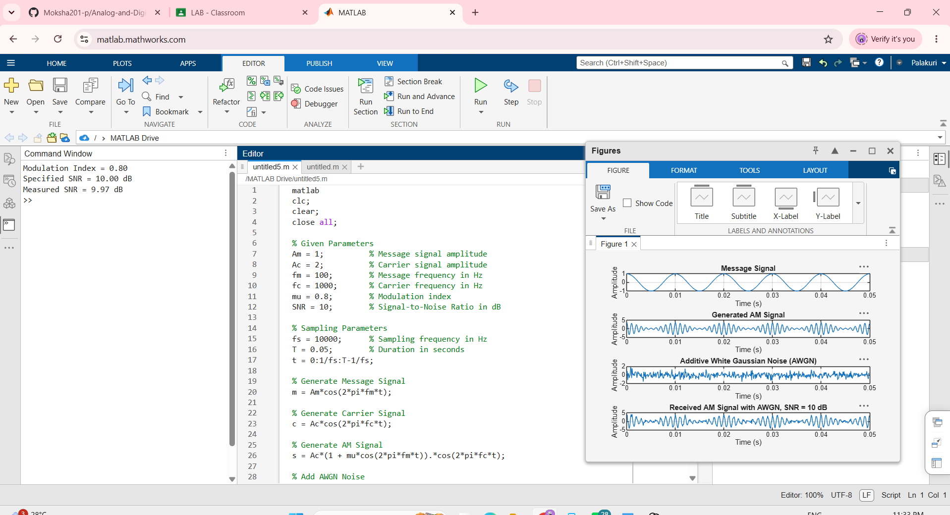
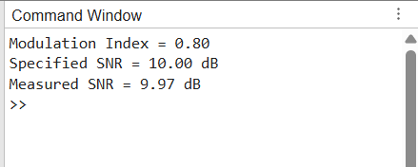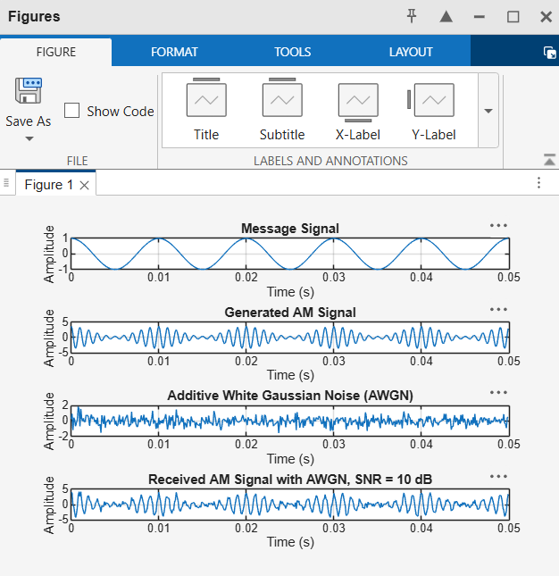

OBJECTIVE:
ii) To recover the original message signal from the noisy AM signal using envelope detection
and compare the transmitted and recovered waveforms to evaluate the performance of the AM communication system.
PROGRAMMING CODE:
clc;
clear;
close all;

% Given Parameters
Am = 1; % Message signal amplitude
Ac = 2; % Carrier amplitude
fm = 100; % Message frequency in Hz
fc = 1000; % Carrier frequency in Hz
mu = 0.8; % Modulation index
SNR = 10; % Signal-to-Noise Ratio in dB

% Sampling Parameters
fs = 10000; % Sampling frequency
T = 0.1; % Duration in seconds
t = 0:1/fs:T-1/fs;

% Generate Message Signal
m = Am*cos(2*pi*fm*t);

% Generate AM Signal
s = Ac*(1 + mu*cos(2*pi*fm*t)).*cos(2*pi*fc*t);

% Add AWGN
signal_power = mean(s.^2);
noise_power = signal_power/(10^(SNR/10));
noise = sqrt(noise_power)*randn(size(s));
r = s + noise;

% Envelope Detection
envelope = abs(hilbert(r));

% Remove DC Component and Recover Message
recovered = (envelope - mean(envelope))/(Ac*mu);

% Calculate Correlation
correlation = corrcoef(m, recovered);
corr_value = correlation(1,2);

% Calculate Mean Squared Error
mse = mean((m - recovered).^2);

% Display Results
fprintf('SNR = %.2f dB\n', SNR);
fprintf('Correlation Coefficient = %.4f\n', corr_value);
fprintf('Mean Squared Error = %.4f\n', mse);

% Plot Results
figure;

subplot(4,1,1);
plot(t,m,'b','LineWidth',1.2);
title('Original Message Signal');
xlabel('Time (s)');
ylabel('Amplitude');
grid on;

subplot(4,1,2);
plot(t,s,'b');
title('Transmitted AM Signal');
xlabel('Time (s)');
ylabel('Amplitude');
grid on;

subplot(4,1,3);
plot(t,r,'r');
title('Received AM Signal with AWGN');
xlabel('Time (s)');
ylabel('Amplitude');
grid on;

subplot(4,1,4);
plot(t,m,'b','LineWidth',1.2);
hold on;
plot(t,recovered,'r--','LineWidth',1.2);
title('Comparison of Original and Recovered Message');
xlabel('Time (s)');
ylabel('Amplitude');
legend('Original Message','Recovered Message');
grid on;
OUTPUT:
